**Try again once you are ready**

**Grade received** 50%

**Latest Submission Grade** 50%

**To pass** 80% or higher

Try again

**1.**

Question 1

Which of the following do you typically see in a ConvNet? (Check all that apply.)

**1 / 1 point**

Expand

**Correct**

Great, you got all the right answers.

**2.**

Question 2

In LeNet - 5 we can see that as we get into deeper networks the number of channels increases while the height and width of the volume decreases. True/False?

**1 / 1 point**

Expand

**Correct**

Correct, since in its implementation only valid convolutions were used, without padding, the height and width of the volume were reduced at each convolution. These were also reduced by the POOL layers, whereas the number of channels was increased from 6 to 16.

**3.**

Question 3

Based on the lectures, in the following picture, which curve corresponds to the expected behavior in theory, and which one corresponds to the behavior we get in practice? This when using plain neural networks.

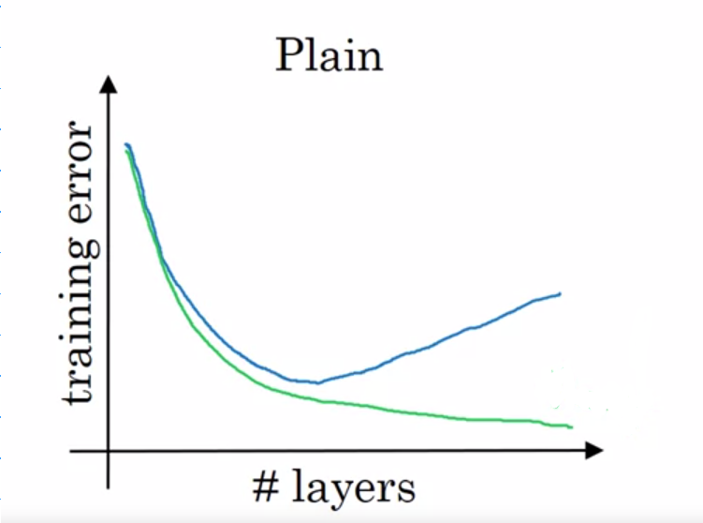

**1 / 1 point**

Expand

**Correct**

Yes, in theory, we expect that as we increase the number of layers the training error decreases; but in practice after a certain number of layers the error increases.

**4.**

Question 4

The computation of a ResNet block is expressed in the equation:

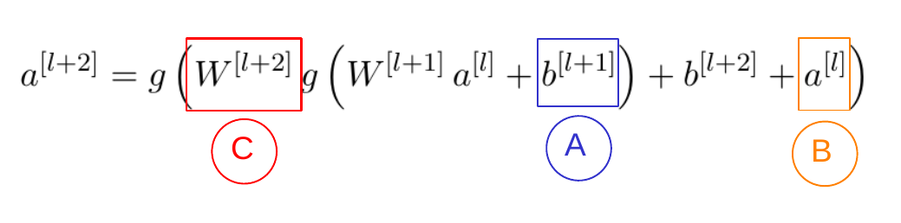

Which part corresponds to the skip connection?

**0 / 1 point**

Expand

**Incorrect**

No, this corresponds to the bias parameter of the $$l+1$$ layer.

**5.**

Question 5

Adding a ResNet block to the end of a network makes it deeper. Which of the following is true?

**0 / 1 point**

Expand

**Incorrect**

No, the ResNet block has a set of parameters so the number of parameters in the networks increases.

**6.**

Question 6

Suppose you have an input volume of dimension n_H*nH*​ x n_W*nW*​ x n_C*nC*​. Which of the following statements do you agree with? (Assume that the “1x1 convolutional layer” below always uses a stride of 1 and no padding.)

**0 / 1 point**

Expand

**Incorrect**

You didn't select all the correct answers

**7.**

Question 7

Which ones of the following statements on Inception Networks are true? (Check all that apply.)

**1 / 1 point**

Expand

**Correct**

Great, you got all the right answers.

**8.**

Question 8

Which of the following are common reasons for using open-source implementations of ConvNets (both the model and/or weights)? Check all that apply.

**1 / 1 point**

Expand

**Correct**

Great, you got all the right answers.

**9.**

Question 9

Which of the following are true about Depth wise-separable convolutions? (Choose all that apply)

**0 / 1 point**

Expand

**Incorrect**

You chose the extra incorrect answers.

**10.**

Question 10

Suppose that in a MobileNet v2 Bottleneck block the input volume has shape 64 \times 64 \times 1664×64×16. If we use 3232 filters for the expansion and 1616 filters for the projection. What is the size of the input and output volume of the depthwise convolution, assuming a pad='same'?

**0 / 1 point**

Expand

**Incorrect**

Incorrect, the input and output volume of the depthwise convolution are the same.

Question 1

When building a ConvNet, typically you start with some POOL layers followed by some CONV layers. True/False?

**1 / 1 point**

Expand

**Correct**

Correct. It is typical for ConvNets to use a POOL layer after some Conv layers; sometimes even one POOL layer after each CONV layer; but is not common to start with POOL layers.

**2.**

Question 2

LeNet - 5 made extensive use of padding to create valid convolutions, to avoid increasing the number of channels after every convolutional layer. True/False?

**1 / 1 point**

Expand

**Correct**

Yes, back in 1998 when the corresponding paper of LeNet - 5 was written padding wasn't used.

**3.**

Question 3

Based on the lectures, in the following picture, which curve corresponds to the expected behavior in theory, and which one corresponds to the behavior we get in practice? This when using plain neural networks.



**1 / 1 point**

Expand

**Correct**

Yes, in theory, we expect that as we increase the number of layers the training error decreases; but in practice after a certain number of layers the error increases.

**4.**

Question 4

The following equation captures the computation in a ResNet block. What goes into the two blanks above?

*a*[*l*+2]=*g*(*W*[*l*+2]*g*(*W*[*l*+1]*a*[*l*]+*b*[*l*+1])+*bl*+2+_______ )+_______

**0 / 1 point**

Expand

**Incorrect**

No, $$a^{[l]}$$ is added before the activation of layer $$l+2$$

**5.**

Question 5

In the best scenario when adding a ResNet block it will learn to approximate the identity function after a lot of training, helping improve the overall performance of the network. True/False?

**0 / 1 point**

Expand

**Incorrect**

Incorrect. When adding a ResNet block it can easily learn to approximate the identity function, thus in a worst-case scenario, it will not affect the performance of the network at all.

**6.**

Question 6

For a volume of 125 \times 125 \times 64125×125×64 which of the following can be used to reduce this to a 125 \times 125 \times 32125×125×32 volume?

**1 / 1 point**

Expand

**Correct**

Yes, since using $$1 \times 1$$ convolutions is a great way to reduce the depth dimension without affecting the other dimensions.

**7.**

Question 7

Which of the following are true about the inception Network? (Check all that apply)

**0 / 1 point**

Expand

**Incorrect**

You didn't select all the correct answers

**8.**

Question 8

Parameters trained for one computer vision task can't be used directly in another task. In most cases, we must change the softmax layer, or the last layers of the model and re-train for the new task. True/False?

**0 / 1 point**

Expand

**Incorrect**

No, this is a good way to take advantage of open-source models trained more or less for the task you want to do. This may also help you save a great number of computational resources and data.

**9.**

Question 9

Which of the following are true about Depth wise-separable convolutions? (Choose all that apply)

**1 / 1 point**

Expand

**Correct**

Great, you got all the right answers.

**10.**

Question 10

Suppose that in a MobileNet v2 Bottleneck block we have an n\times n \times 5*n*×*n*×5 input volume, we use 3030 filters for the expansion, in the depthwise convolutions we use 3 \times 33×3 filters, and 2020 filters for the projection. How many parameters are used in the complete block, suppose we don't use bias?

**0 / 1 point**

Expand

**Incorrect**

No, recall that we are not using bias.

[**Skip to Main Content**](https://www.coursera.org/learn/convolutional-neural-networks/exam/40woH/deep-convolutional-models/attempt?redirectToCover=true#main)

[[](https://www.coursera.org/)](https://www.coursera.org/)

Top of Form

SEARCH IN COURSE



Search

Bottom of Form

* Pema Wangdi

1. [Convolutional Neural Networks](https://www.coursera.org/learn/convolutional-neural-networks/home/welcome)
2. [Week 2](https://www.coursera.org/learn/convolutional-neural-networks/home/week/2)
3. Deep Convolutional Models

[**Previous**](https://www.coursera.org/learn/convolutional-neural-networks/ungradedLti/i3hXl/lecture-notes-w2)[**Next**](https://www.coursera.org/learn/convolutional-neural-networks/supplement/CxKVT/note-on-the-upcoming-programming-assignment-residual-networks)

## Case Studies

## Practical Advice for Using ConvNets

## Lecture Notes (Optional)

## Quiz

**[Quiz:](https://www.coursera.org/learn/convolutional-neural-networks/exam/40woH/deep-convolutional-models)**[Deep Convolutional Models](https://www.coursera.org/learn/convolutional-neural-networks/exam/40woH/deep-convolutional-models)

[10 questions](https://www.coursera.org/learn/convolutional-neural-networks/exam/40woH/deep-convolutional-models)

## Programming Assignments

# **Deep Convolutional Models**

Quiz50 minutes • 50 min

### Submit your assignment

**Due** October 30, 11:59 PM UTCOct 30, 11:59 PM UTC

**Attempts** 3 every 24 hours

Try again

Retake the quiz in **23h 43m**

### Receive grade

**To Pass** 80% or higher

### Your grade

70%

View Feedback

We keep your highest score

Like

Dislike

Report an issue

Top of Form

Bottom of Form

**Back**

# Deep Convolutional Models

Graded Quiz. • 50 min

**Due**Oct 30, 11:59 PM UTC

**Try again once you are ready**

**Grade received** 70%

**Latest Submission Grade** 70%

**To pass** 80% or higher

Retake the assignment in **23h 43m**

### 1.

Question 1

When building a ConvNet, typically you start with some POOL layers followed by some CONV layers. True/False?

**1 / 1 point**

Expand

**Correct**

Correct. It is typical for ConvNets to use a POOL layer after some Conv layers; sometimes even one POOL layer after each CONV layer; but is not common to start with POOL layers.

### 2.

Question 2

In order to be able to build very deep networks, we usually only use pooling layers to downsize the height/width of the activation volumes while convolutions are used with “valid” padding. Otherwise, we would downsize the input of the model too quickly.

**1 / 1 point**

Expand

**Correct**

Correct!

### 3.

Question 3

Training a deeper network (for example, adding additional layers to the network) allows the network to fit more complex functions and thus almost always results in lower training error. For this question, assume we’re referring to “plain” networks.

**1 / 1 point**

Expand

**Correct**

Correct, Resnets are here to help us train very deep neural networks.

### 4.

Question 4

The following equation captures the computation in a ResNet block. What goes into the two blanks above?

*a*[*l*+2]=*g*(*W*[*l*+2]*g*(*W*[*l*+1]*a*[*l*]+*b*[*l*+1])+*bl*+2+_______ )+_______

**1 / 1 point**

Expand

**Correct**

Correct

### 5.

Question 5

Which ones of the following statements on Residual Networks are true? (Check all that apply.)

**1 / 1 point**

Expand

**Correct**

Great, you got all the right answers.

### 6.

Question 6

1 \times 11×1 convolutions are the same as multiplying by a single number. True/False?

**0 / 1 point**

Expand

**Incorrect**

No, a $$1 \times 1$$ layer doesn't act as a single number because it makes a sum over the depth of the volume.

### 7.

Question 7

Which ones of the following statements on Inception Networks are true? (Check all that apply.)

**1 / 1 point**

Expand

**Correct**

Great, you got all the right answers.

### 8.

Question 8

Which of the following are common reasons for using open-source implementations of ConvNets (both the model and/or weights)? Check all that apply.

**1 / 1 point**

Expand

**Correct**

Great, you got all the right answers.

### 9.

Question 9

In Depthwise Separable Convolution you:

**0 / 1 point**

Expand

**Incorrect**

You didn't select all the correct answers

### 10.

Question 10

Fill in the missing dimensions shown in the image below (marked W, Y, Z).

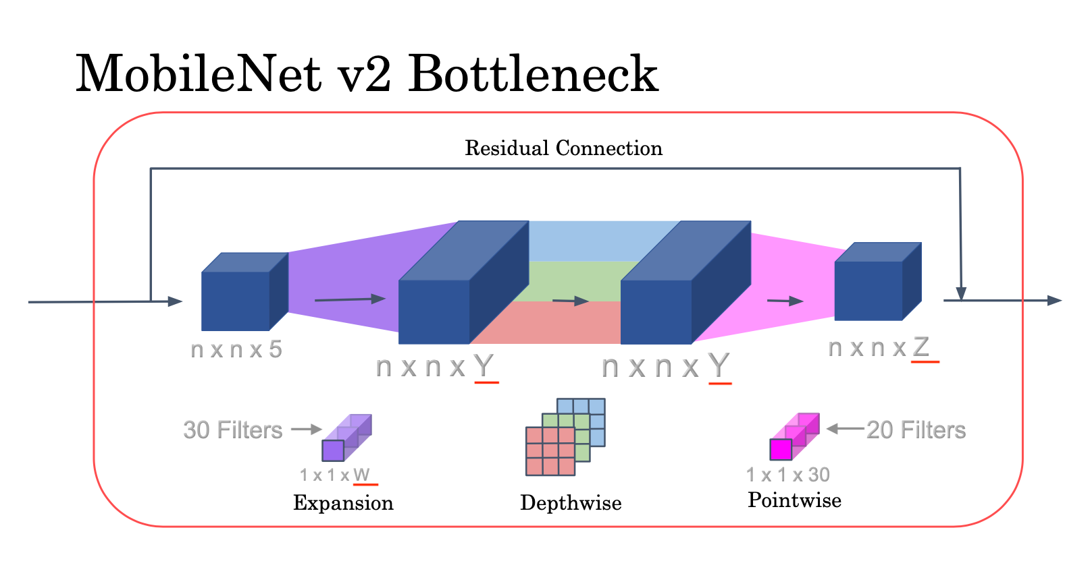

**0 / 1 point**

Expand

**Incorrect**

Incorrect! To improve your understanding, watch the lecture MobileNet Architecture.